SOLAR PLANT Test Report - VAMK

**Version 1.2**

**8.12.2019**

**Project Team:**

Md Farukul Islam, Manager

Carlos Martinez de la Riva Valdaliso, Developer/Reporter

Albin Westerlund, Developer/reporter

**Document Author:** Albin Westerlund

E1701460

# IntroductionThis document functions as the test report for the test made of the related functions/code. If more tests are needed, they can be added to the test report in the next chapter. Test are assigned to different project members so that the workload is equally divided between members. When a test is executed, the result can be added/changed in the test report section in following chapter.

# Test Report

|  |  |  |  |
| --- | --- | --- | --- |
| Test ID | Description | Expected Results | Actual Results |
| 001 | Test that the WRM module in Technobotnia is sending the correct data from Vacon 8000 | A live feed of generated power is uploaded to IoT Ticket | Looks to be correct. It is only sending when the sun is shining. |
| 002 | Test to see if the values of the estimated production is sent to the right datanode | Correct data is shown on IoT Ticket’s graph | Sending is not working, we got the correct data |
| 003 | IoT Ticket power produced previous year. | Dashboard chart show produced power for the previous year. | Working |
| 004 | IoT Ticket power produced previous month. | Dashboard chart show produced power for the previous month. | Working |
| 005 | IoT Ticket power produced today. | Dashboard chart show produced power for today. | Working |
| 006 | Python script should send updated data on estimated production when run. | Dashboard chart show the estimated production. | Python script is not yet sending. Problem with IoT Ticket libraries. |

# Test Version 1.1

The graphs for the production are working and showing correct looking data. Graphs are corresponding to the amount of sun, so they are showing less production for darker or cloudier days. We have compared them to Vaasan Sähkö’s graphs and they correspond. We are still working on the estimated production based on cloud data.

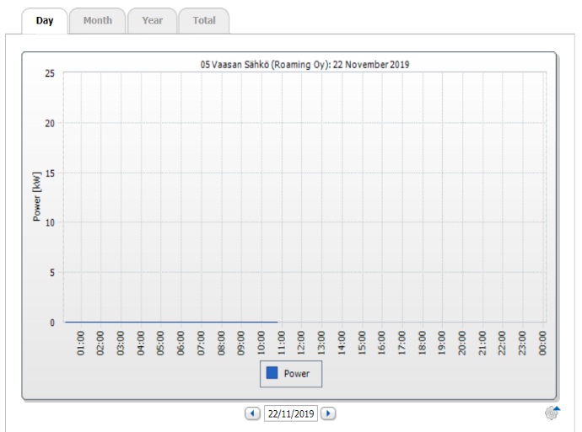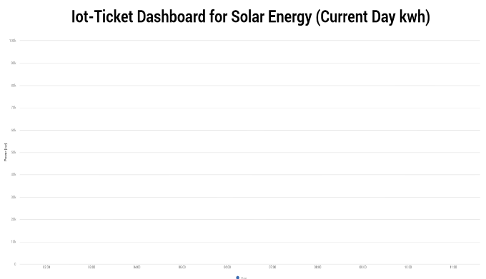

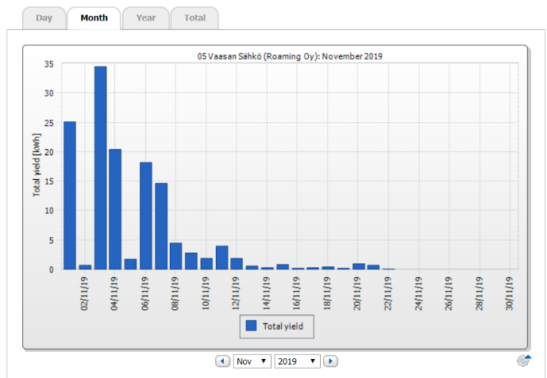

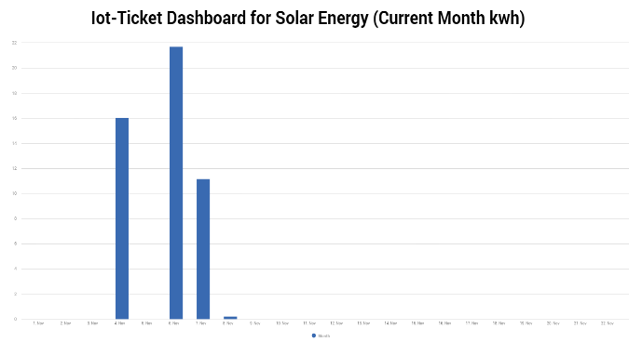

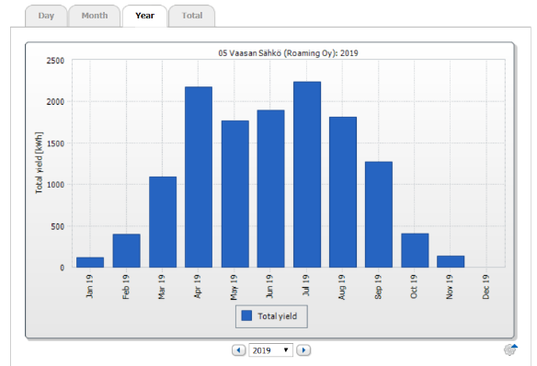

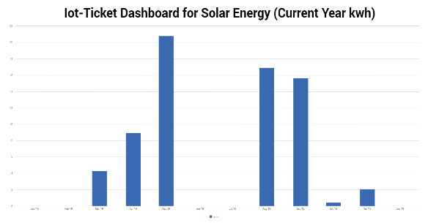

# Test Version 1.2

Everything else is working but the estimated production. Problem is that the python script is not sending estimated production data to IoT Ticket data node. Still under construction.

# Document Revision History:

|  |  |
| --- | --- |
| Version | 1.2 |
| Name(s) | Albin Westerlund |
| Date | 8.12.2019 |
| Change Description | Changed test 002. Added test 006. |